

Ordering form  Date:  Quotation number: | Microelectrodes Ltd  orders@microelectrodes.net  tel. +44 7503 311208

Please fill out light blue fields only.
Bill to: (please provide complete address) |  | Deliver to: (please provide complete address)
Institution |  | Institution
Department |  | Department
Name |  | Name
Street |  | Street
Town |  | Town
Post code |  | Post code
Telephone |  | Telephone
Email |  | Email

Ordered items:
Electrode specification  e.g. tungsten / 125 / 76 / 12.5 / unplated / pin 220-P02/dura removed | Number  of boxes | Price per box [GBP] | Amount [GBP]

Handling and shipping 15[GBP] per box |  | 13

NL04 coupler  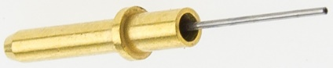 | Number of NL04 | Price per NL04 [GBP]
 |  | 15

 | Total | [GBP]

Filled out form please send to email orders@microelectrodes.net for quotation.

We try to realise each order as soon as possible, however we reserve maximum delivery lead time of 4 weeks.
All import charges or any other custom fees are covered by the buyer.

